Library Management System

System Description

The System is designed to be used at any school library. First, the software will have the ability to store and delete information about books. Second the System will store and delete information about students. Finally, when used by a Librarian the System will have the ability to borrow books to students. This process will also assign a return date and a fine if not return before return date. All this information will be stored and can be accessed anytime.

Development Software

* Java
* MySQL
* JavaFx

Subsystems

* Book Management
  + This subsystem will handle the store and removal of books into the system. It will also have the option of modify any information in any book. This will be available to a librarian.
* Student Management
  + This subsystem will handle the store and removal of student’s information into the system. It will also have the option of modify any information in any student’s information. This will be available to a librarian.
* Book Lending/return
  + This subsystem will be responsible for the management of book lending. It will have the option to assign a limited number of books to a student. When a book is returned the subsystem will remove the book record that was assigned to the student. If the book is return after a certain date the subsystem will determine a fine to the student.
* Loging user
  + The subsystem will handle the login for both users (Librarian, member). It will determine the access that each user will have and to send the user to the right interface.

System Requirements

|  |  |  |
| --- | --- | --- |
| Req # | Req Name |  |
| **Book Management** | ------------------------ |  |
| FR1 | Add book |  |
| FR2 | Remove book |  |
| FR3 | Edit book |  |
| FR4 | View book |  |
|  |  |  |
| **Student Management** | ------------------------ |  |
| FR100 | Add student |  |
| FR101 | Remove student |  |
| FR102 | Edit student |  |
| FR103 | View student |  |
|  |  |  |
| **Book Lending/Return** | ------------------------ |  |
| FR201 | Assign book |  |
| FR202 | Remove book |  |
| FR203 | Assign student |  |
| FR204 | Remove student |  |
| FR205 | Change student |  |
| FR206 | Change book |  |
| FR207 | Add fine |  |
| FR208 | Remove fine |  |
| FR209 | Add fine |  |
| FR210 | Remove fine |  |
| FR211 | Add return date |  |
| FR212 | Remove return date |  |
|  |  |  |
| **Book Catalog** | ------------------------ |  |
| FR301 | Search book |  |
| FR302 | Check status |  |
| FR303 | View book |  |
|  |  |  |
| **Login user** | ------------------------ |  |
| FR500 | Member user |  |
| FR501 | Librarian user |  |
|  |  |  |

* Implementation Phases
* Database Schema
* Login Screen
* Librarian GUI
* Member GUI
* Testing
* Bug Fixes

Use cases Diagram

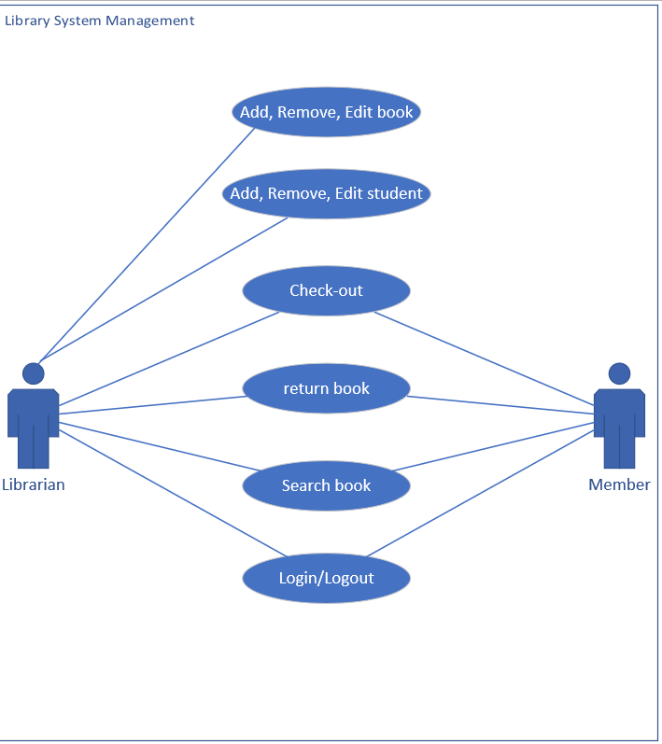

Database Schema

